Cognitive Home - Watson Visual Recognition Lab
Created by Shubhradeep Nandi (AI, Cognitive and DataScience expert)

objective
To verify if Watson visual recognition system can distinguish between smile and Anger. This is something that has never been tried before.

CREATE THE APPLICATION BASE
- Click on the https://console.ng.bluemix.net/catalog/starters/node-red-starter/
- Create a Node-Red Application
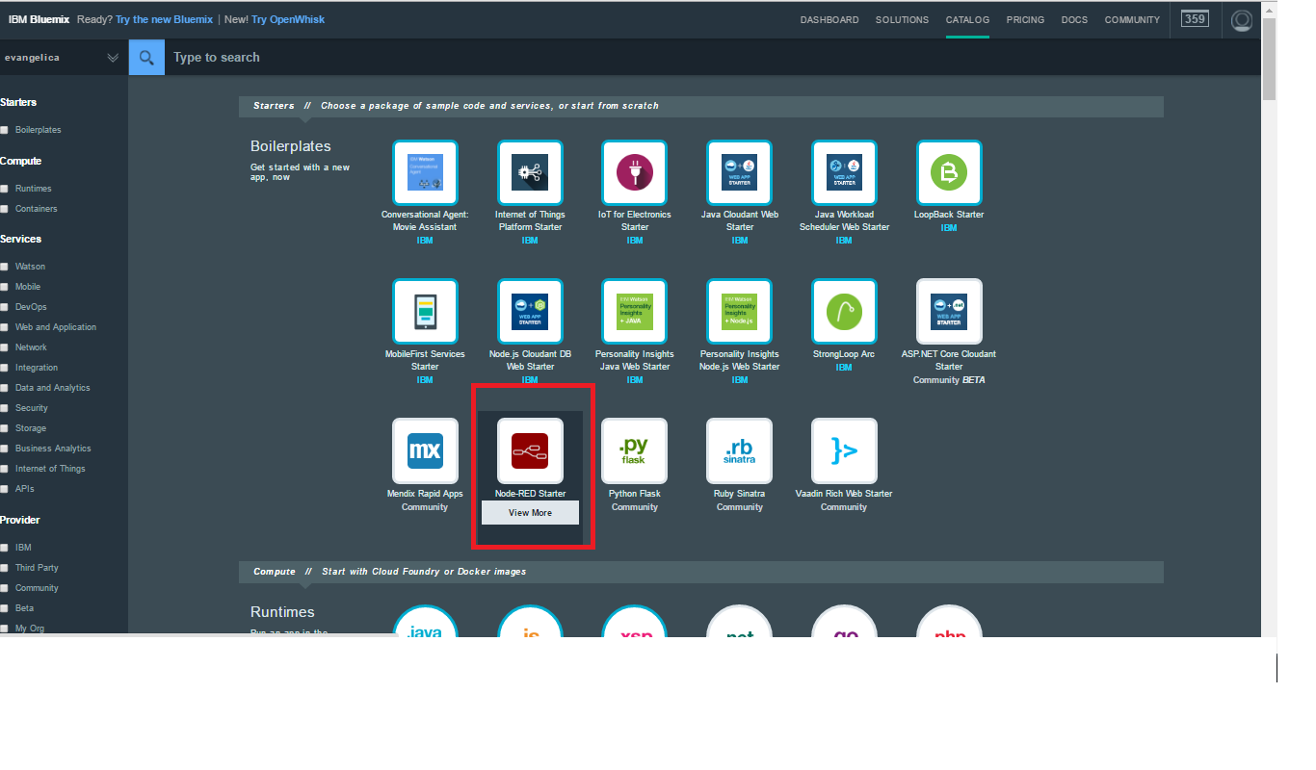

- Add a Watson Visual Recognition service to the application.
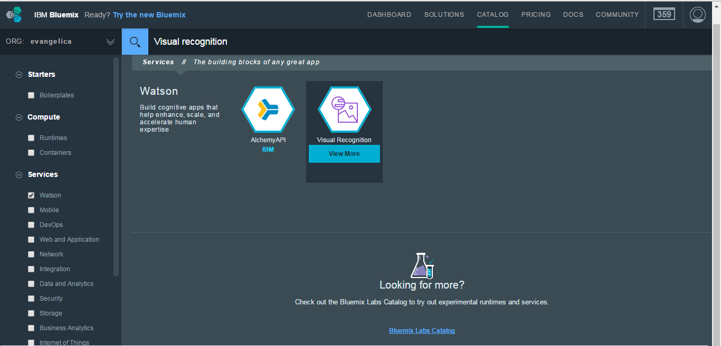
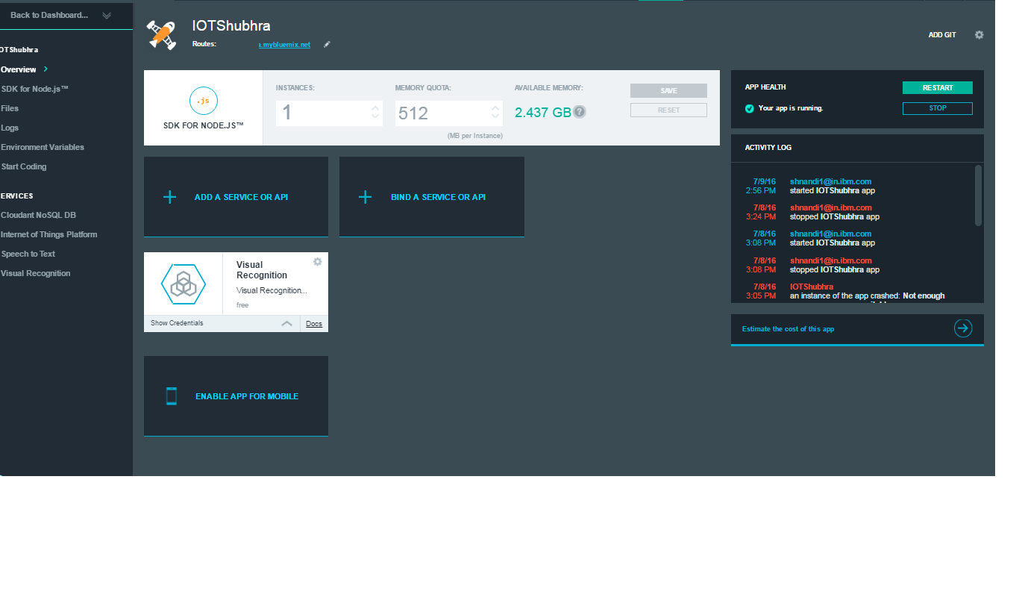

Training the system
- Take around 20 smiley selfies and 20 angry selfies of a single Individual.
- Take around 20 images where this individual is neither smiling nor angry.
- Resize the images to 600X800 pixel in size.
- Create a zip file each for two set of images name them as smile.zip and anger.zip.
- Go to http://visual-recognition-demo.mybluemix.net/train
- Try to upload your zip files and create a custom classifier.
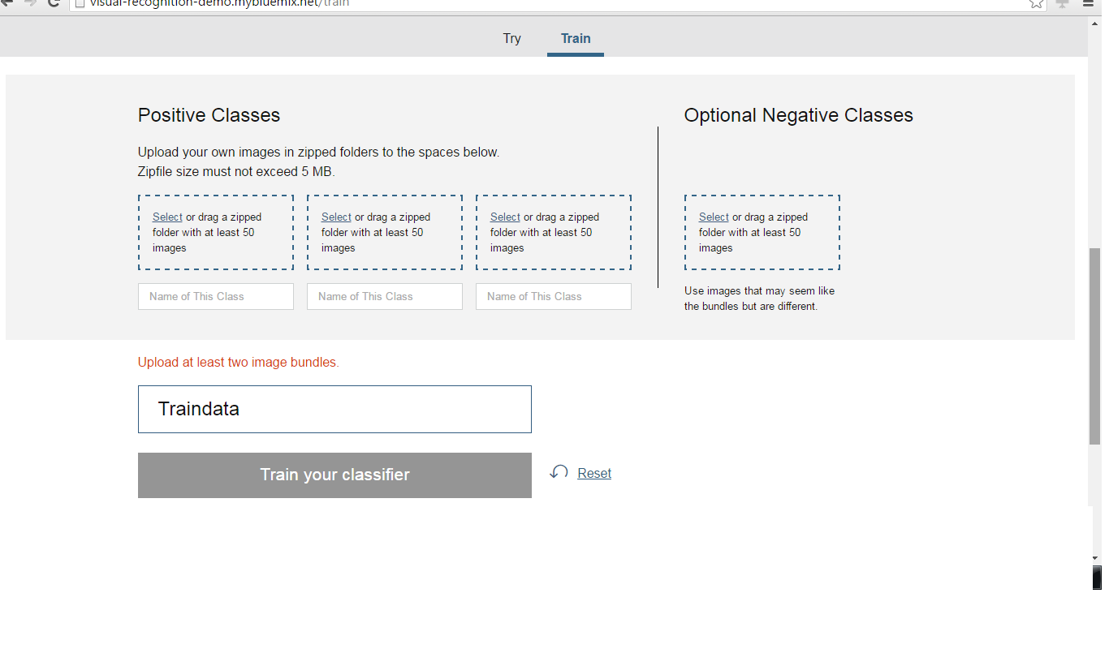
- If step 3 does not work for you then follow step 5-7
- (Optional) Alternatively, open up the command prompt.
- (Optional) Go to your folder where the selfie zips are stored.
- (Optional) Run the below curl command to train.
- curl -X POST -F "< smile-name>_positive_examples=@smile.zip" -F "< anger_positive_examples=@ anger.zip" -F "negative_examples=@negative.zip" -F "name=selfiesec" "https://gateway-a.watsonplatform.net/visual-recognition/api/v3/classifiers?api_key=<Your_API_KEY>&version=19-05-2016"
- This will take up to a maximum 15 minutes for the system to get trained with your customer data.
- Note the classifier id for future references.

creating the your visual authentication system.
- Go to GitHub repo https://github.com/ShubhradeepNandi/WatsonLabs.git and click on watch + star + fork
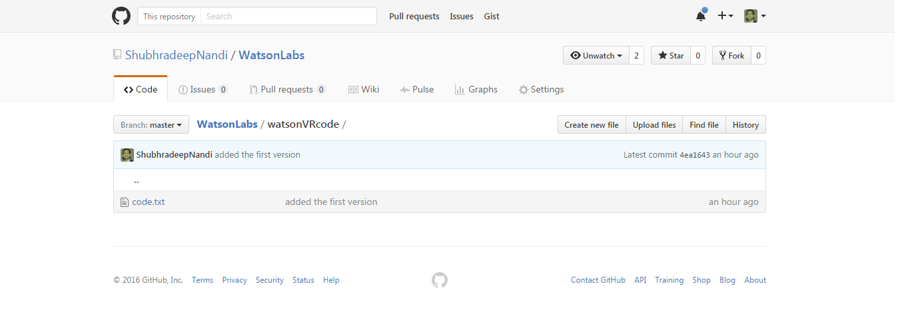
- Get the code.txt from watsonVRcode
- Import the code text in to Node Red application Sheet space.
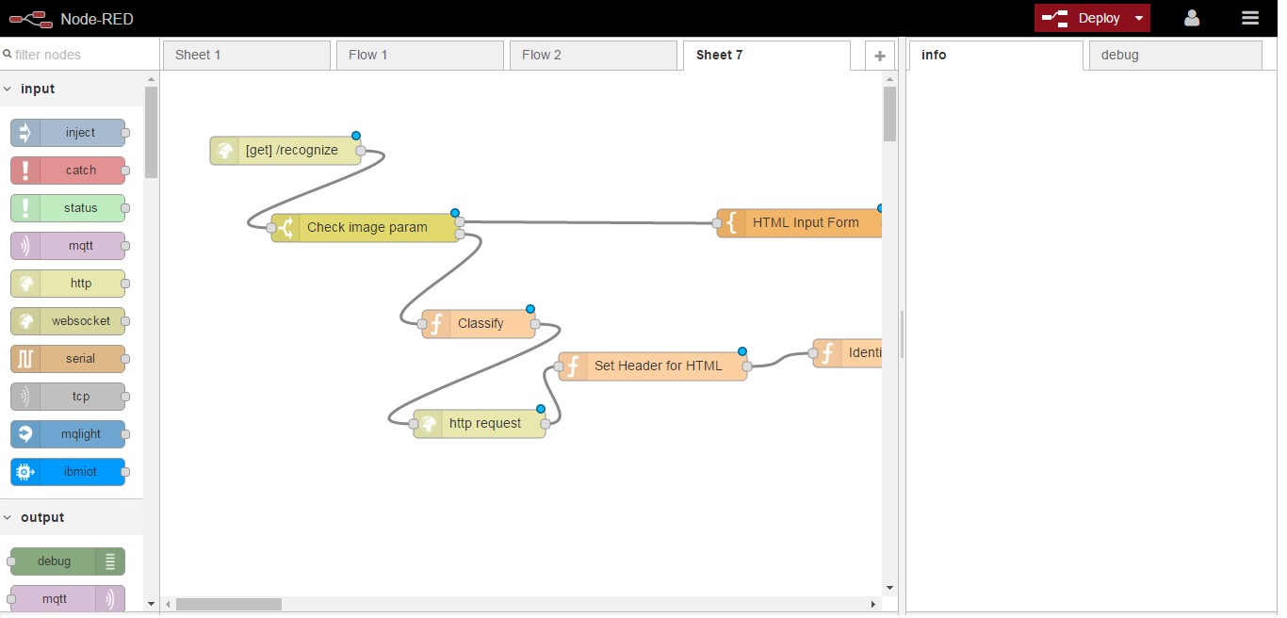
- Modify the below items :-
- In the Classify function node modify this line “msg.url="https://gateway-a.watsonplatform.net/visual-recognition/api/v3/classify?&api_key=1234myapikey&url="+encodeURI(msg.payload.url)+"&classifier_ids=<ADD YOUR OWN CLASSIFIER ID>&owners=me,IBM&threshold=0.2&version=19-05-2016";”
- In the Identification function node modify this line “if(msg.class === '<Add your first class>' || msg.class === '<Add your second class>'){ “
- Deploy the code and you are done.

Test it out

- Make a GET call to the below API :-
- <Your Node Red App url> /recognize?url=<Image url>
- A parameter ‘url’ should be appended to the api call where you need to send an Image URL [How and where to upload an Image will be informed during the Lab]
- This application will send a JSON response in the below format :-
{"custom_classes":2,"images":[{"classifiers":[{"classes":[{"class":"smile","score":0.237042}],"classifier_id":"myclassifier","name":"selfiesec"}],"resolved_url":"https://****/$$$$/shubhra2.jpg","source_url":"https://****/$$$$/shubhra2.jpg"}],"images_processed":1,"authorize":1}
‘class’ is the parameter to look for.

